Résumé

[Attirez votre lecteur avec un résumé attrayant. Il s’agit généralement d’une brève synthèse du document.   
Lorsque vous êtes prêt à ajouter votre contenu, cliquez ici et commencez à taper.]

Introduction to ict technologies

TIC Final Project

**Contents Tables:**

|  |  |
| --- | --- |
| Contents | Page |
| * Introduction to ICT | 2 |
| * Some of ICT technologies and tools: | 3-10 |
| * Some benefits of ICT | 11 |

**Introduction to ICT:**

Today, computing is commonplace. It's obvious that it's been adopted by us as a regular part of our professional and personal lives, as a result of advances in the telecommunications field, Information and Communication Technologies (ICT) are now experiencing a rapid increase in development. ICT combines all of the technologies and instruments used to process (hardware and software) as well as communicate (communication networks) information in digital form. This concerns the majority of areas of our daily lives, including education, transportation, commerce, the medical and military fields, nothing can function without it. As a student, it's important to know how to utilize specific ICT tools.

**But what is ICT?**

ICT, or information and communications technology (or technologies), is the infrastructure and components that enable modern computing, among the goals of IC technologies is improving the way people create, process and share data or information with each other. Another is to help them improve their skills in many areas, including business. education; medicine …

Note that there is no universal definition of ICT because of the constant evolution of the technologies, devices and even ideas related to ICT. However, we generally use this term meaning all devices, networking components and applications. When combined, these help people and organizations interact in the digital world.

**Some of ICT technologies and tools:**

We can name a lot, but among the main actors we have :

Google Services :

Google offers a wide range of services that cater to various needs of users. Here are some of the key Google services:

* **Google Search:**

- The world's most popular search engine, providing users with quick and relevant search results.

* **Gmail:**

- A widely used email service with a user-friendly interface, efficient spam filtering, and seamless integration with other Google services.

* **Google Calendar:**

- A web-based calendar application that helps users organize their schedules, events, and appointments. It can be easily shared and synchronized across devices.

* **Google Maps:**

- A mapping service that provides directions, traffic conditions, and local business information. It also offers features like Street View and satellite imagery.

* **Google Photos:**

- A cloud-based service for storing and sharing photos and videos. It includes features like automatic backup, intelligent organization, and facial recognition.

* **YouTube:**

- A video-sharing platform where users can upload, share, and view videos. It covers a wide range of content, including educational videos, entertainment, and more.

* **Google Chrome:**

- A web browser developed by Google known for its speed, simplicity, and security features. It also supports a wide range of extensions.

* **Google Docs, Sheets, and Slides:**

- Part of Google Drive, these are online document, spreadsheet, and presentation tools that enable real-time collaboration among multiple users.

* **Google meet:**

- A video conferencing service that allows users to host virtual meetings, webinars, and collaborative sessions. It integrates with Google Calendar.

* **Google Drive:**

- A cloud storage service that allows users to store and share files, documents, photos, and videos. It also includes Google Docs, Sheets, and Slides for online document creation and collaboration.

* **Google Classroom:**

- An online platform designed for teachers and students to facilitate communication, collaboration, and assignment management in an educational setting.

* **Google Analytics:**

- A web analytics service that provides insights into website traffic, user behavior, and other crucial data for website owners and marketers.

* **Google Ads:**

- An online advertising platform where businesses can create and manage ads to reach their target audience through Google's advertising network.

* These are just a few examples, and Google continually develops and introduces new services and features to meet the evolving needs of users
* **This table shows number of users of the most popular google services in 2021**

**(in billions) :**

|  |  |  |  |  |
| --- | --- | --- | --- | --- |
| **Service** | **Chrome** | **YouTube** | **Drive** | **Gmail** |
| **Users** | **3.229** | **2.5** | **1** | **1.5** |

Microsoft Tools :

* **Microsoft Word:**

Microsoft Word is a word processing application developed by Microsoft as part of the Microsoft Office suite. It is one of the most used word processors in the world, providing users a bunch of tools and features for creating, editing, and formatting documents. Let’s have an overview of some features of Microsoft Word:

|  |  |
| --- | --- |
| **Document Creation and Editing:** | Microsoft Word allows users to easily create and edit documents. It provides a user-friendly interface with various commands for formatting, styling, and organizing content. |
| **Templates:** | A big variety of templates is available for different document types, such as resumes, letters, reports, and newsletters. Templates provide a pre-designed structure, saving time for the users. |
| **Page layout and design:** | Users can control the layout and design of their documents by adjusting many options like margins, orientation, page size, and spacing and page elements like headers, footers, and page numbers. |
| **Collaboration and Comments:** | Microsoft Word supports real-time collaboration, this allows multiple users to work on a document simultaneously. collaborators can leave comments and review edits ensuring the success of group projects |
| **Integration with other Microsoft office app:** | Microsoft Word impeccably integrates with other Microsoft Office apps, such as Excel and PowerPoint, That allows using different Data from all the office app in Word. |
| **Cross-Platform Availability:** | Available for Windows, macOS, iOS, and Android, Microsoft Word allows users to easily create and edit documents flawlessly on every device they have making creating document simpler for the users. |
| **Version History and Backup:** | Every time a user edits a document, Microsoft Word automatically saves the current version of the document. This allows users to search for previous versions of documents and create backups to prevent document loss due to software or device issues. |

Thanks to all these features and many more Microsoft word is the best-known and most widely used text editor in the world and that's going to be the case for a long time to come as the software becomes more efficient and powerful with each update.

* **Microsoft Excel:**

Microsoft Excel is a powerful spreadsheet application developed by Microsoft as part of the Microsoft Office suite, it is widely used in data analysis, computing, visualization and information organization. Excel is an important tool in many sectors such as finance, business and education.

Let’s have an overview about some of it features:

|  |  |
| --- | --- |
| **Spreadsheet Creation :** | Excel provides a grid interface that allows users to create and organize data into rows and columns. Each intersection of rows and columns is called a cell and can contain text, numbers, formulas, or functions. |
| **Data Analysis and Visualization:** | Including many tools for data analysis such as filtering and sorting which allows the user to transform his data to graphs and tables making it easier to him visualizing trends and analyzing the data. |
| **Data Import and Export:** | Excel supports the import and export of data form many sources and in different formats like txt, csv and data bases. |
| **Formulas and Functions:** | This feature makes performing calculations using formulas and functions much easier and its one of his most known features. |
| **Data Security:** | Excel provides features to protect sensitive data, including password protection and encryption options for workbooks. This ensures confidential information protection. |

Microsoft Excel also include **Templates, collaboration** and **Integration with other Microsoft office app** like Word do.

.

* That was some of the features that make Microsoft Excel more efficient, powerful and more flexible This has contributed to its popularity and its use by a large number of users and Microsoft is always improving it and updates it often to add new features and make it more accessible to beginners in order to broaden the popularity of the software.
* **Microsoft PowerPoint:**

The Microsoft Office suite also include a presentation software called PowerPoint It facilitates users in creating interesting visualizations with text, images, and multimedia using the multiple features that the software includes and that for various purposes and in many fields such as business, education, marketing and healthcare.

Here's an overview of the key features and functionalities of Microsoft PowerPoint:

|  |  |
| --- | --- |
| **Slide Creation and customization:** | PowerPoint provides a slide-based interface where users can create individual slides with text, images, charts, graphs, and multimedia elements. The platform allows for easy customization of slide layouts and designs |
| **Transition Effects:** | PowerPoint offers a range of transition effects that can be applied between slides, adding more professional touch to the project. What’s even better is that these transitions are not one-size-fits-all you can tweak and customize them to match the vibe and content of your presentation |
| **Animations:** | It allows the user to add movement and dynamic transitions to the slides to bring elements on their slides to life. Animation options include entrance, exit, emphasis, and motion paths, allowing for creative and attention-grabbing presentations. |
| **Presenter View:** | Presenter View offers presenters the advantage of viewing speaker notes, upcoming slides, and a timer on their screen, all while ensuring that the audience sees only the current slide, this is one of the main features that make PowerPoint that efficient and that popular. |
| **Multimedia Integration:** | PowerPoint gives the possibility of including multimedia elements, such as images, videos, and audio files so users can insert media directly into their slides to create more engaging and dynamic presentations. |

Microsoft PowerPoint also includes **Collaboration** and **Integration with other Microsoft office app** like Word and Excel.

* Microsoft PowerPoint's user-friendly interface, coupled with its rich set of features, makes it a widely used tool for creating great looking presentations in various professional and educational fields.

Git and GitHub:

* **Git:**

Git is a distributed version control system (VCS) designed to handle everything from small to very large projects with speed and efficiency. Git has become the de facto standard for version control, especially in the open-source community. It enables developers to track changes, collaborate seamlessly, and maintain a history of their codebase.

Git graphic interface :

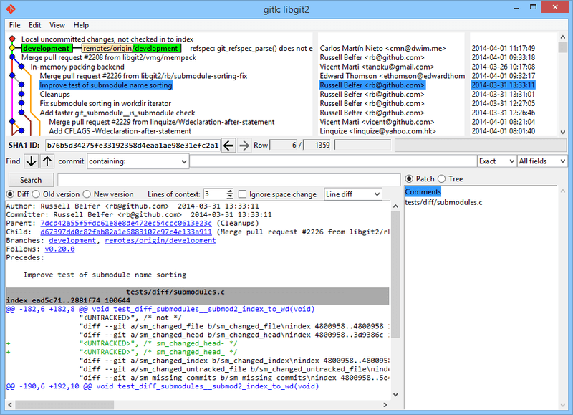

Some of it concepts:

* **Repository:**

A Git repository, is a collection of files and directories along with the version history information stored by Git

* **Commit:**

A commit represents a snapshot of the changes made to the codebase at a specific point in time. Each commit has a unique identifier.

* **Branch:**

A branch is a separate line of development. Git allows branching, enabling developers to work on features or bug fixes without affecting the main codebase. Branches can be merged back when the changes are ready.

* **Merge:**

Merging combines changes from different branches. It can be done manually or automatically by Git when changes do not conflict.

* **Pull Request:**

In Git-based collaboration, a pull request is a proposed set of changes. It allows others to review and discuss the code before merging it into the main codebase.

* **Push:**

Pushing involves sending committed changes from the local repository to a remote repository. It updates the remote repository with the latest changes made locally.

And some of it benefits:

* **Collaboration:**

Git facilitates collaboration by allowing multiple developers to work on a project simultaneously.

* **History Tracking:**

Git maintains a detailed history of changes, making it easy to understand who made what changes and when.

* **Distributed Development:**

Git's distributed nature allows developers to work offline and synchronize changes when a connection is available.

* **Branching:**

Branching in Git allows for experimentation and the development of features in isolation, reducing conflicts and making code reviews more manageable.

* The most popular Git hosting platform is **GitHub.**

Git has become an integral part of modern software development, playing a crucial role in enabling teams to work efficiently, collaborate seamlessly, and maintain a robust history of their codebases. Its flexibility and scalability make it suitable for projects of all sizes.

* **GitHub:**

GitHub is a web-based platform built on top of Git, the distributed version control system. Launched in 2008, GitHub has become the go-to platform for developers, providing tools for version control, collaboration, code review, and project management. It has played a pivotal role in fostering open-source development and supporting distributed teams worldwide.

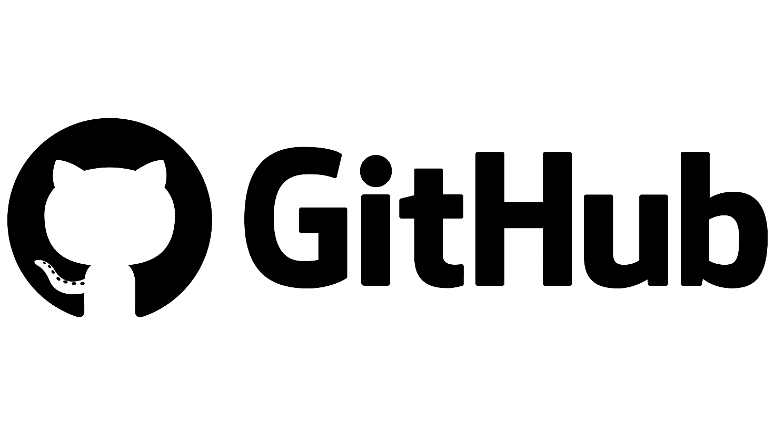

Some of it Concepts:

|  |  |
| --- | --- |
| **Git Repository Hosting:** | GitHub hosts Git repositories, allowing developers to store, manage, and collaborate on their code. Each repository comes with its version history, issues, and pull requests. |
| **Collaboration and Forking:** | Users can fork repositories to create their copies, allowing them to experiment or contribute without affecting the original project. Collaboration is enhanced through pull requests, where changes are proposed and discussed. |
| **Issues and Bug Tracking:** | GitHub provides an issue tracking system to report bugs, discuss features, or propose enhancements facilitating project management. |
| **Pull Requests:** | Pull requests are a way to propose changes to a repository. They are used for code review, discussions, and merging changes into the main codebase. |
| **Code Review:** | GitHub's interface includes features for reviewing code changes. Comments can be added to specific lines, discussions can take place, and suggested changes can be incorporated before merging. |
| **Security and Dependency Scanning:** | GitHub provides tools for identifying and resolving security vulnerabilities in code. It can also scan dependencies for known vulnerabilities. |
| **Integrations and APIs:** | GitHub integrates with a wide range of tools and services. Additionally, it offers a many API for building custom integrations |

And some of it benefits:

* **Collaboration:**

GitHub enables collaboration among developers globally. Open-source projects benefit from a diverse community, and private repositories support secure collaboration within organizations.

* **Community and Learning:**

GitHub provides an environment for learning, sharing knowledge, and building a developer's profile. Contributions to open-source projects and discussions within the community contribute to a developer's professional growth.

* **Project Management:**

GitHub's project management features, including issues, projects, and boards, streamline collaboration and make it easier to manage tasks within a team.

* **Scalability:**

GitHub is designed to handle projects of all sizes, from small personal repositories to large enterprise-level codebases.

**Some of ICT benefits:**

* **Improved Communication:**

ICT facilitates instant communication through emails, messaging apps, video conferencing

* **Increased Efficiency and Productivity:**

By improving communications and coordination through various tools This leads to increased efficiency and productivity in various industries.

* **Increasing Motivation:**

By providing interactive and engaging learning experiences and also getting quick feedback on own work and performance helping people understanding their strengths and areas for improvement.

* **Innovation and Creativity:**

ICT tools provide platforms for innovation and creative expression. From software development to many other fields.